Jagjot Singh

Dr. Nilesh Patel

CSI4999

1/23/2020

**LogBook Entry For Sprint 1**

I wasn’t sure how you wanted the proof for the work but I did two all nighters and drank a lot of coffee. Heres what I did, and can you provide feedback so I know what I can do for next logbook thanks in advance!

1. Developed backend server on google cloud

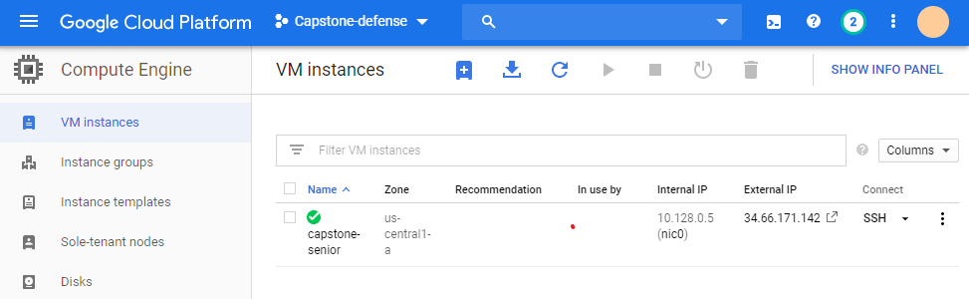

Setup the server in Ubuntu LTS 16, and created a LAMP server or (linux, apache2, mysql, and php). This virtual machine instance is being used to host the website at the moment. **Effort hours: ~3-4 hours** → mostly because issues arise with setting permissions for mysql reading.

1. Created tables in mySQL and ERD diagrams *UPDATE* status was added to table

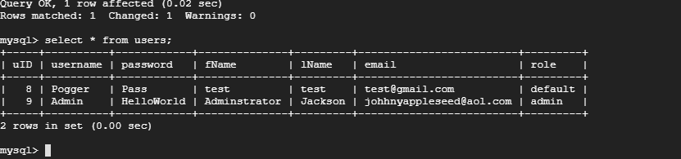

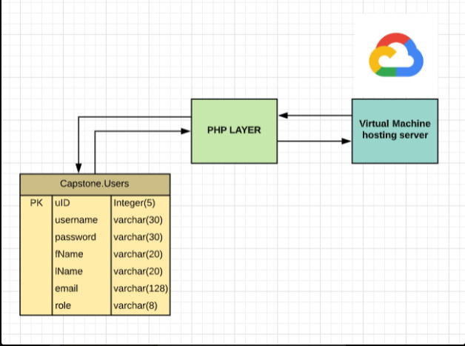

1. Created front end design for website: **All front end code can be viewed in website folder for master. Effort Hours: ~4-5 hours *number varies refer uptop**

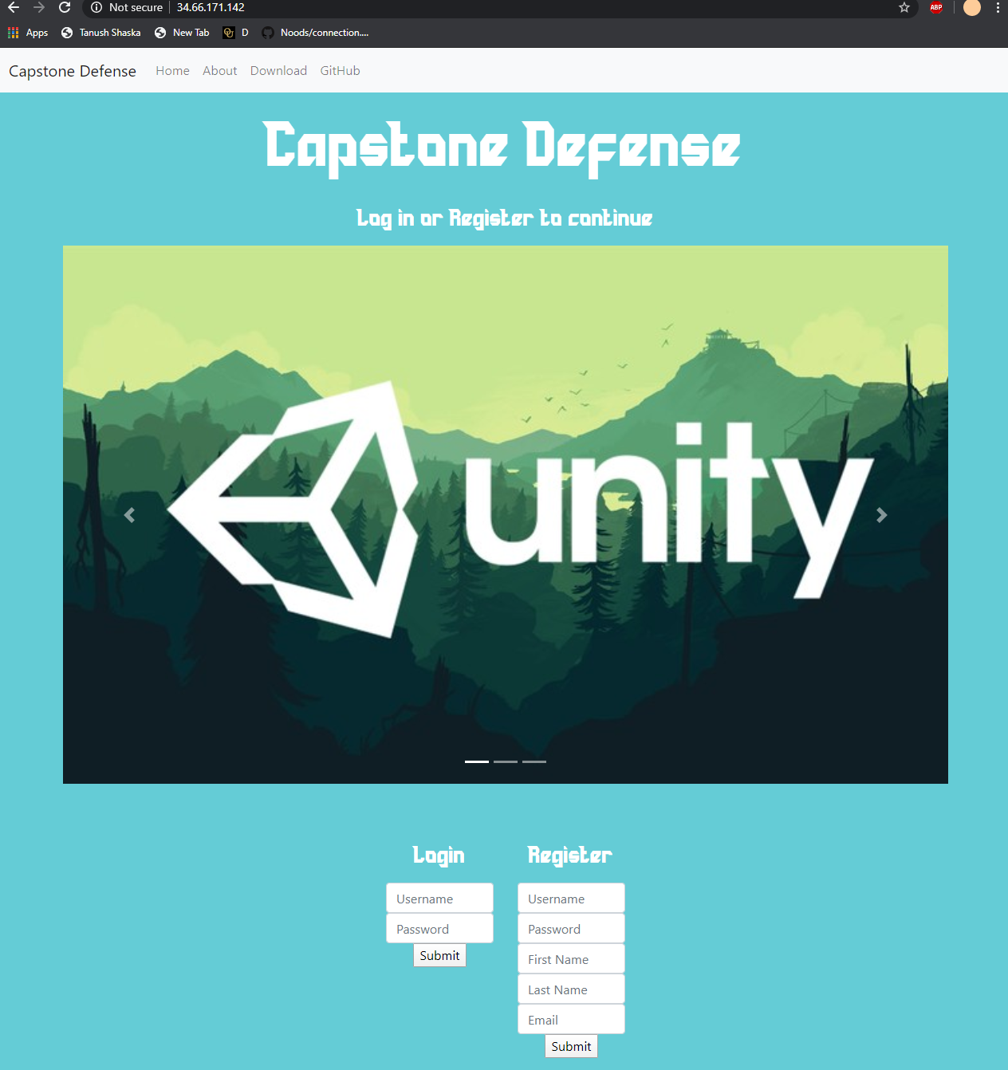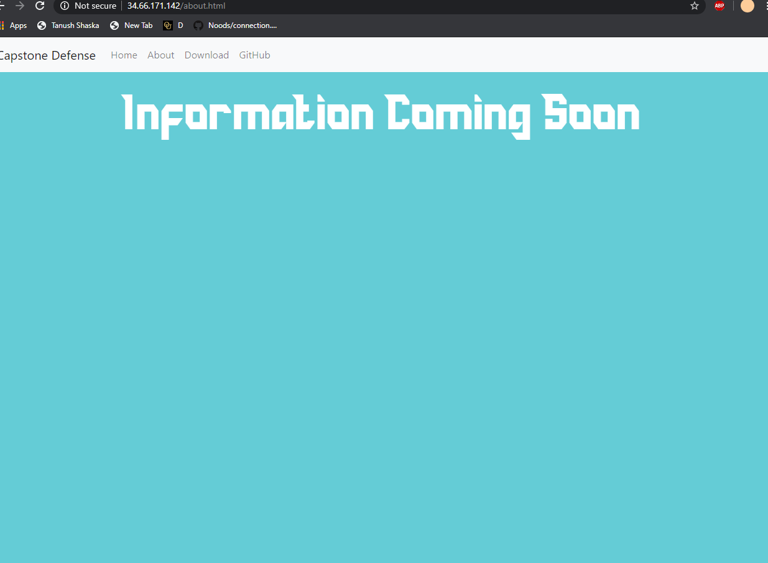

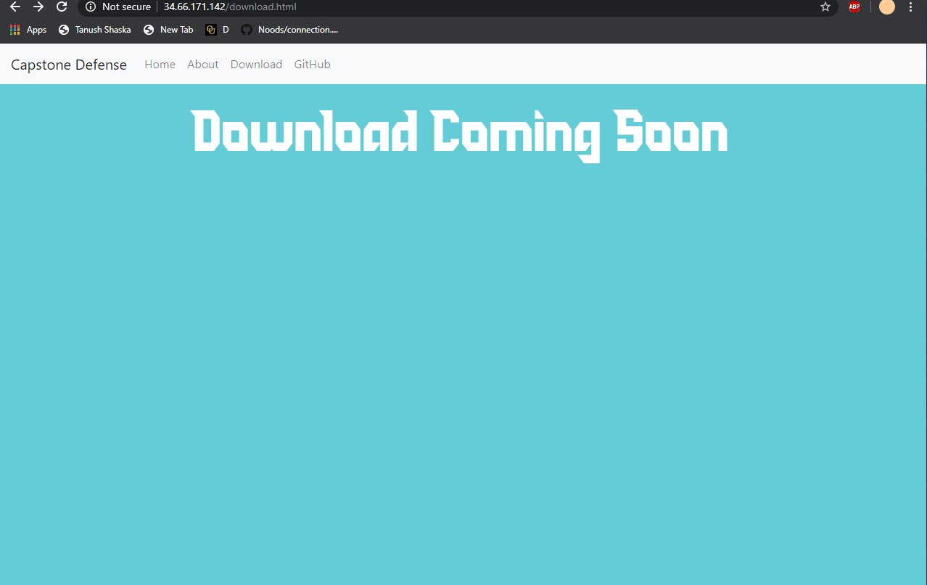

1. Backend connections to sql server and php made so users can register and input **~2-3 hours**
2. Setting up email server to send out emails: **Effort Hours ~3 hours**

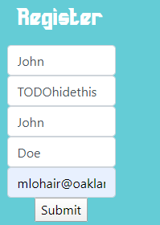

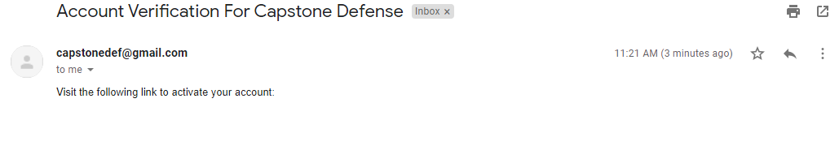

1. Creating code to handle security, behavior of inputs, and clean up of front end/backend

**~5-6 hours**

These include:

**Carosoul view**

**Different php files**

**Email server clean up**

**Registration fix for incorrect inputs**

**….**

**Alot more but I didn’t log everything**

1. Worked on presentation **~1 hour**